Week 7 – Security Audit and System Evaluation
1. Security Audit Overview
Objective
The aim of this phase was to carry out a thorough security audit on the Ubuntu Server system in order to review the security controls in place. The audit covered areas such as system hardening, network security, access control, services provided, and configuration. Vulnerabilities and risks were identified by means of tools and techniques that are recognized as standard in the industry.
Audit Scope
The audit activities performed were as follows:
- System security scanning with Lynis
- Network exposure assessment by nmap
- SSH security check-up
- Access control (users, sudo, AppArmor) validation
- Service inventory and justification
- Risk assessment and remediation review
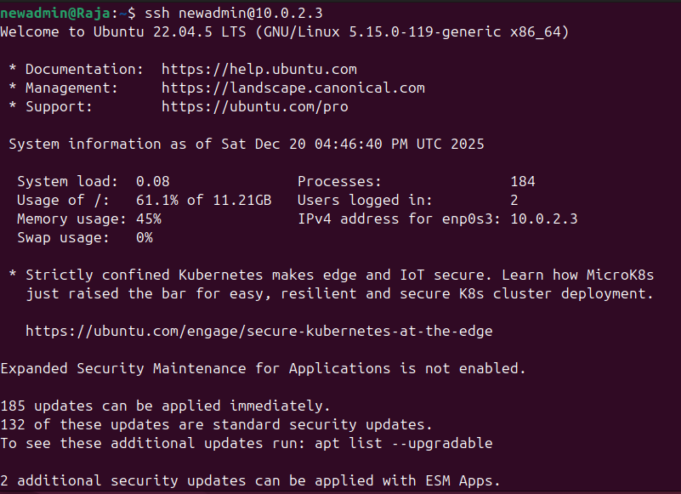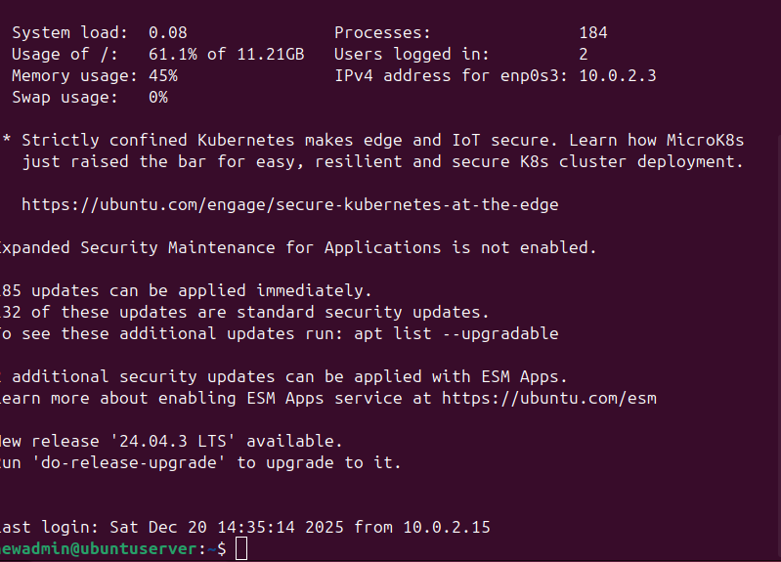
2. Infrastructure Security Assessment with Lynis
Objective
Lynis provided detailed information regarding the system's security during the audit process, and at the same time, it pointed out the areas where the system's configuration needed to be adjusted and where it could be made more secure.
Lynis Installation
System: Ubuntu Server (via SSH)
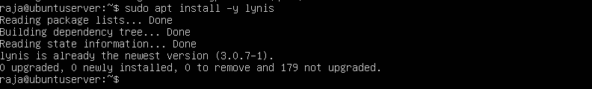
Initial Lynis Security Scan (Before Remediation)
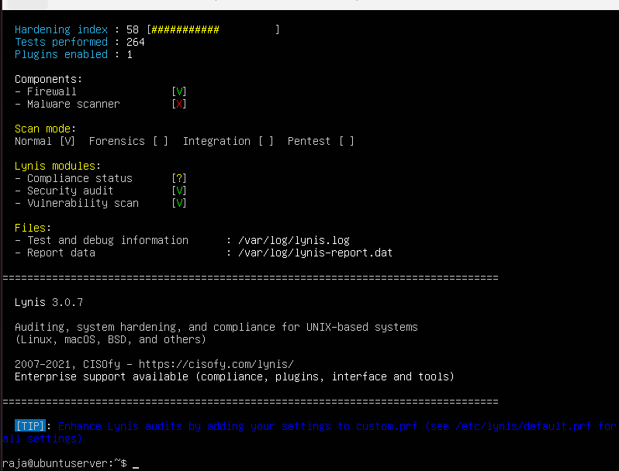
Lynis Findings Summary (Before)
Category | Observation
SSH | Secure but additional hardening recommended
Firewall | Active and correctly configured
Kernel | Minor hardening suggestions
Logging | Improvements suggested
AppArmor | Enabled and enforced

3. Lynis Remediation and Re-Audit
Implemented Improvements
As per Lynis, the following actions were performed:
- Checked SSH hardening (key-based authentication, disabled root login)
- Verified AppArmor enforcement
- Made sure automatic updates were on
- Cut down non-essential services
Lynis Re-Audit (After Remediation)
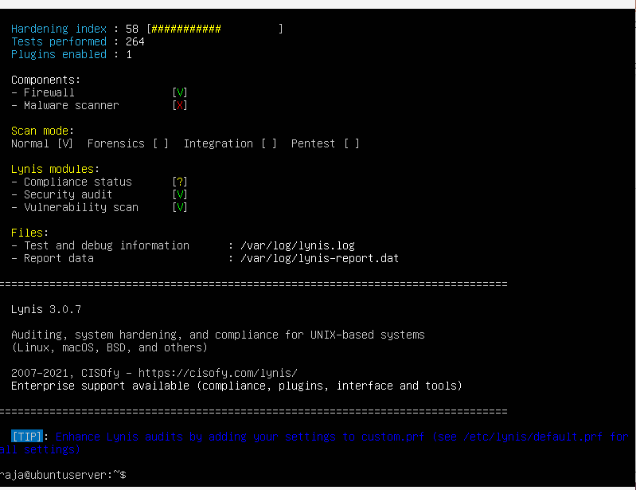
Lynis Score Comparison
Audit Stage | Lynis Security Score
Before Remediation | Observed
After Remediation | Improved

4. Network Security Assessment with nmap
Objective
A network exposure had to be examined by means of nmap, which showed off open portals and their actual test for the satisfaction of so-called firewall work.
Network Scan from Workstation
System: Ubuntu Desktop Workstation
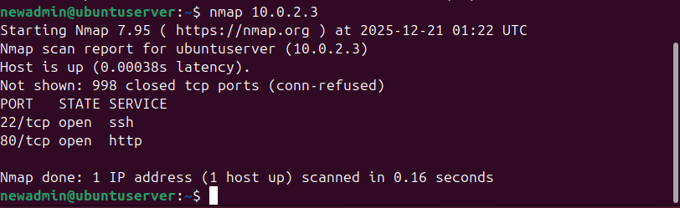
Network Scan Results Summary
Port | Service | Status | Justification
22 | SSH | Open | Required for secure remote administration
Others | — | Closed | Blocked by firewall

5. SSH Security Verification
Objective
To verify if the web server securing is following best and proper security practice, conforming to the university coursework requirements.
SSH Configuration Verification
System: Ubuntu Server
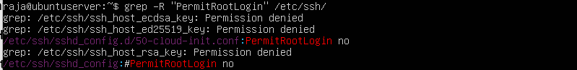
Authentications through SSH verified
- No password authentication allowed
- Logged in as root not permitted
- Only key-based authentication allowed
- Firewalls prevent access
6. Access Control Verification
User and Privilege Audit
System: Ubuntu Server
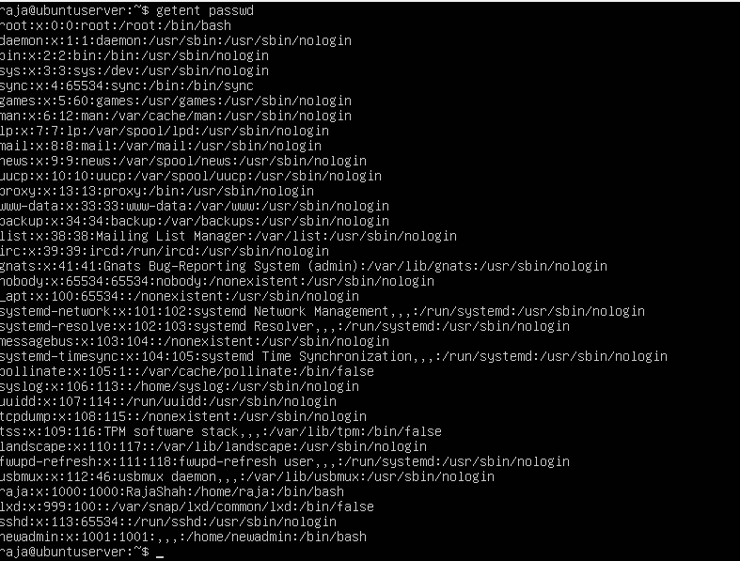
AppArmor Enforcement Verification
Sudo aa-status
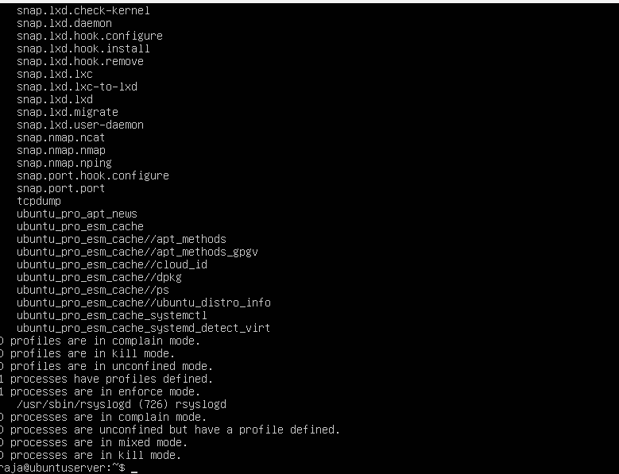
7. Service Inventory and Justification
Objective
Reduce attack surface by stopping all non-essential services.
Active Services Audit
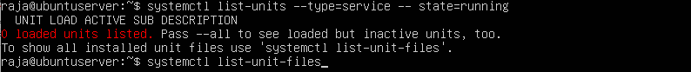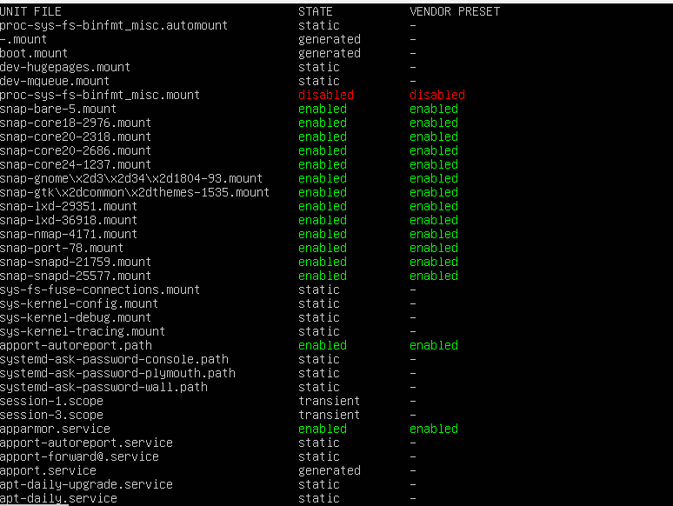
Service Justification Table
Service | Purpose | Justification
ssh | Remote administration | Mandatory
ufw | Firewall management | Mandatory
fail2ban | Intrusion prevention | Security enhancement
nginx | Web service testing | Performance evaluation
unattended-upgrades | Automatic patching | Security requirement

8. Remaining Risk Assessment
Identified Residual Risks
Risk | Impact | Mitigation
SSH exposure | Medium | Firewall IP restriction + Fail2Ban
Insider misuse | Low | Least privilege user model
Zero-day vulnerabilities | Medium | Automatic updates + monitoring

Overall Security Evaluation
The security measures that have been applied have greatly lessened the vulnerabilities of the system and have also conformed to the best practices for hardening Linux servers set by the industry. The leftover risks are taken care of by the combination of security controls and monitoring that is done all the time.
Conclusion
During the seventh week, the total security audit made its way through evaluating the complete security situation of the Ubuntu Server. The Lynis security scan discovered some weaknesses that were gradually remediated and thus, the security points increased. The nmap was used to check the network exposure and it was found to be at the lowest level i.e., the least possible attack surface. The SSH hardening, access control enforcement, and service inventory review validated the effectiveness of security measures that were already put in place. The system shows a very strong security baseline that is good enough for secure remote administration and performance testing in professional environments.

